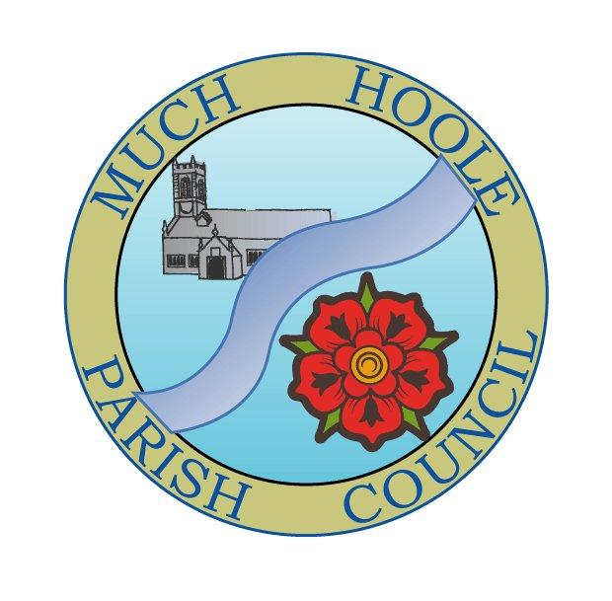 | MUCH HOOLE PARISH COUNCIL  NOTICE OF MEETING
You are hereby summoned to attend the Meeting of Much Hoole Parish Council to be held on Monday 14th December 2020. The meeting will be held remotely via Zoom video technology under the provisions of the emergency Coronavirus legislation.

In the interests of transparency of Council business, the agenda is printed below. Any member of the public who wishes to comment or have their views heard at the meeting should contact the Clerk by email as follows: clerk@muchhoolepc.org.uk

You may also log into the meeting at 7.30pm Monday 14th December 2020 via Zoom using
Meeting ID974 2841 6906 Password 241570

Russ Weaver, Clerk to the Parish Council

AGENDA
1. | Apologies for Absence  To receive apologies for absence.
2. | Declaration of Interests and Dispensations  - To receive declarations of interest from Councillors on items on the agenda  - To receive written requests for dispensations for disclosable pecuniary interests (if any)  - To grant any requests for dispensation as appropriate
3. | Minutes of the Previous Meeting  To resolve to approve as a correct record the Minutes of the Council Meeting held on 9th November 2020
4. | Public Time  The published agenda contains an opportunity for members of the public to raise any general concerns or issues in relation to items under discussion via the Clerk. Any such contact from members of the public will be dealt with at this item. Anyone wishing to join the meeting should email the Clerk on clerk@muchhoolepc.org.uk or use the following Zoom login details Meeting ID974 2841 6906 Password 241570  The Clerk has been asked to raise the issue of recent flooding on Town Lane / Lunds Lane on behalf of a resident
5. | Off Road Cycle Track  To consider any updates on the Cycle track and resolve any actions required.
6. | Village Hall Update  - To receive an update on progress towards completion of a new village hall (paper circulated to Cllrs with agenda papers)
7. | Finance  To resolve to note and /or authorise payment of the following:  To NOTE that new nationally agreed pay scales apply to the Clerk (effective from 1st April 2020)  - To resolve to pay Clerk in sum of salary for November 2020 plus backpay in sum of £268.00(net) See breakdown of calculations in attached papers.  - To resolve to pay Clerk mileage expenses in sum of £8.55  - To resolve to pay HMRC PAYE for November 2020 and backpay in sum of £67.00  - To resolve to pay G McKenna for Lengthsman services in the sum of £402.52 (invoices 82,84,86 and 87)  - To Note that £90,000 has been drawn down from CCLA and placed in Council Unity Trust accounts. This leaves a zero balance in CCLA  - To Note the bank reconciliation as at 29th November 2020
8. | Standing Orders  To consider the following proposal:  To add to Standing Order 4e: ‘A serving Chairman may not be considered for re-election as Chairman if he/she has completed the previous three consecutive years as Chairman.’
9. | Budget and Precept. (To include allocation of CIL money within budget)  To consider the draft budget, consider any amendments, additions or subtractions, allocate the use of CIL money within the budget and to resolve to set a budget and precept for 2021-2021.
10. | Planning items  07/2020/00987/HOH November 25, 2020  Single storey rear extension following demolition of existing garage and conservatory  11A Smithy Lane, Much Hoole, Preston, Lancashire, PR4 4GN
11. | Reports from meetings  To receive reports from any relevant meetings attended by Councillors  - LALC area Committee notes  - LALC AGM
12. | Items for the Next Agenda (for information only)
13. | Date of Next Meeting  The Parish Council to agree the date of the next meeting as 7.30pm Monday 11th January 2021 (format will be subject to prevailing Govt guidance)

